**Century Furniture Grand Convex Mirror**

**Price: $5200**

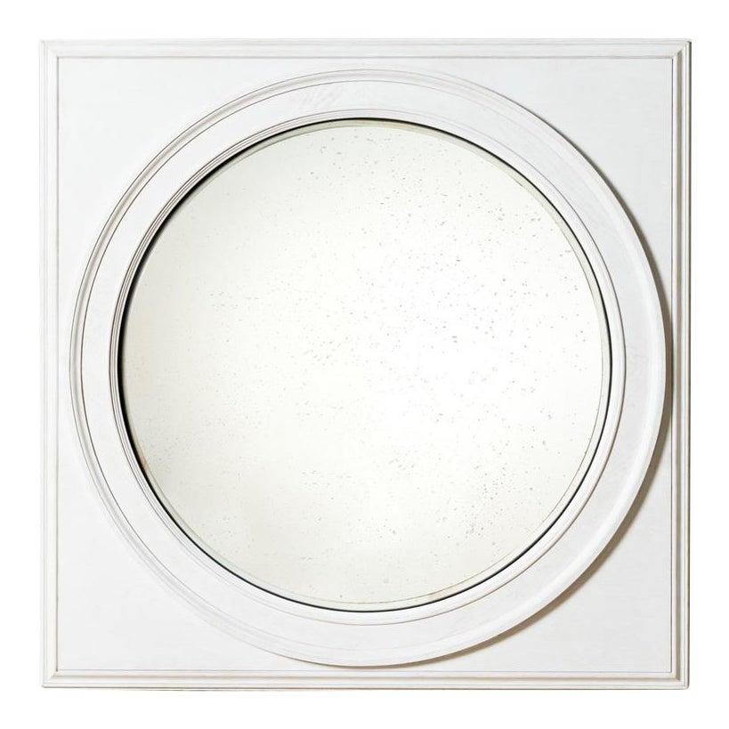

* CATEGORIES

Dressing Room

* MATERIALS

Decorative Mirrors

* SHAPE

Circle

* BRAND

Inax